Sadie’s Star
Written and Illustrated by Samara Collins

This book is written in loving memory of my daughter and first born child, Sadie Elizabeth Collins. Sadie was born on 30th December 2009 and survived until 10th September 2010 with a condition called Edwards Syndrome (Trisomy 18).

To learn more about Trisomy, please visit SOFT UK’s website http://www.soft.org.uk. All proceeds for this book will be donated to children’s charities including SOFT UK.

Forward

To be added

For Patrick, Sadie’s little brother and my darling son.

One December morning a baby girl was born. She was very tiny and very beautiful. Her mummy and daddy thought she was a very special little girl so they named her Sadie, which means ‘Princess’.

Sadie’s mummy and daddy were right – she was very special. Very soon, they were told that Sadie was a precious gift for them to keep for a while. She wouldn’t stay long, because she was needed in Heaven, but they could have some very happy times with her and Sadie could make some friends here on Earth before the angels would need her back.

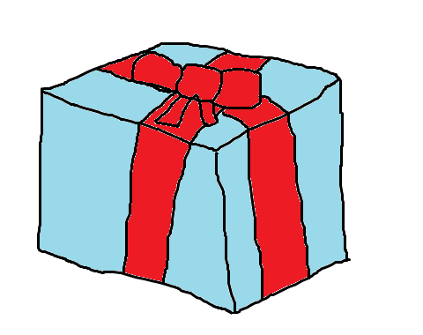

Sadie’s mummy and daddy were told that she was very poorly and very precious so they would need to be extra careful with her.

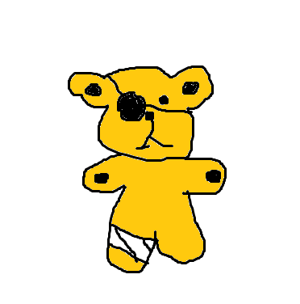

Sadie’s mummy and daddy brought her home from the hospital and showed her all around her home and introduced her to the family’s black and white cat, Clive.

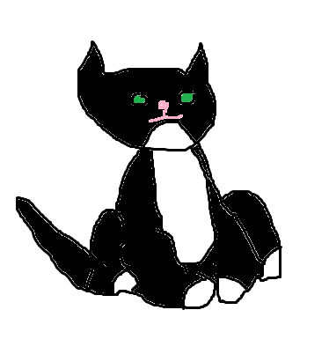

Sadie had lots of toys and her favourite was a little grey elephant named Nelly. At night, she liked to lie in her cot, sucking her big green dummy and gazing at her toys.

Sadie had lots of friends and enjoyed meeting other children. Although she was too little to join in, she enjoyed watching them play, listening to them sing songs and letting them help her with her dummy.

One rainy day in September the angels came to visit as they needed Sadie to join them now, so she would need to leave her mummy and daddy and live happily in Heaven with her great grandparents.

Sadie’s mummy and daddy were very sad, but they knew they had been lucky to have Sadie and that she had a special job to do in Heaven. They also knew that Heaven is very beautiful and that Sadie would be very happy.

Although Sadie is busy in Heaven, playing, flying and having fun, from time to time she likes to send special messages, to say hello to everyone.

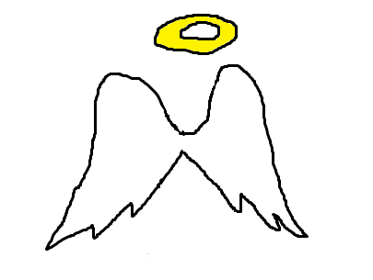
Sometimes she sends a big bright rainbow....

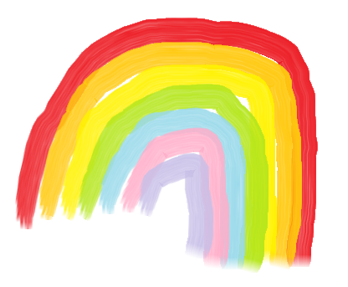

Or a gentle, warm breeze....

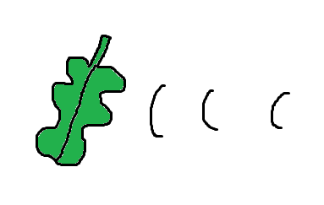

Other days she sends white feathers....
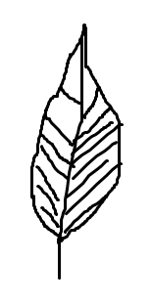

But her favourite of all is her very own star! So when you look up at the stars at night and if you look very carefully, you can see Sadie’s star is always shining the brightest.

The End

Thanks
To be written

A Note from the Author

Dear Reader,

When Sadie was born in December 2009 my husband, Drew and I had no idea that she would be diagnosed with Edwards Syndrome 24 hours later. The support we received from our hospital, GPs, friends, family, local community, SOFT UK and Francis House Children’s Hospice (to name just a few) was vital to us. I set up a website to share news of Sadie and to reach out to other parents in similar circumstances. This proved to be a real comfort over the weeks, months and years that followed.

Losing our little girl 8 months later has been very painful, but we treasure the memories of her life with us and I continue to enjoy sharing her story.

When pregnant with Sadie’s younger brother, Patrick, I decided I would write a short book to explain who his sister was and to tell him about her life. Since sharing this book with friends, I decided to share it more widely and decided to publish Sadie’s Star and I hope other families may find Sadie’s Star helpful when discussing the loss of a child with children.

We all have different beliefs of course, and this book expresses mine. My belief that Sadie is in Heaven and remains very real to us is a huge comfort to me and so this book is written with the best intentions – to offer comfort.

Thank you so much for purchasing this book. It’s proceeds will help some very worthwhile children’s charities.

For more information about Sadie, you can visit my website http://sadiecollins.yolasite.com/.

Warm wishes

Sam

First edition written and published online 2009 and this edition published in the UK in 2013.

Text copyright © 2013 Samara Collins
Illustrations copyright © 2013 Samara Collins

©All rights reserved and moral rights asserted.

ISBN TBC

